Database create-Project

create database project;

use project;

Table-Supplier

create table supplier (sid varchar(20) primary key,sname varchar(30),username varchar(30),password varchar(15),address varchar(500),phone varchar(10));

insert into supplier values('s1','Ram Kumar','kr2345','123456','West Bengal','9976543210');

insert into supplier values('s2','Rita Kumari','kr1234','abc123','Uttar Pradesh','9748234512');

select * from supplier;

Table-Customer

create table customer (cid varchar(20) primary key,cname varchar(30),username varchar(30),password varchar(15),email varchar(50),phone varchar(10),address varchar(500));

insert into customer values('c1','Aharna Laha','aharnalaha98','aharna1234','aharnalaha98@gmail.com','9087123456','West Bengal');

insert into customer values('c2','Manvi Shah','@manvishah','manvi1234','manvishah@gmail.com','7278987654','Uttar Pradesh');

select * from customer;

Table-Courrier

create table courrier (coid varchar(20) primary key,address varchar(500),phone varchar(10),deliveryDate date,paymentType varchar(50),cname varchar(30),price float);

insert into courrier values ('co1','West Bengal','9087123456','2021-02-09','Debit Card','Aharna Laha',1839.0);

insert into courrier values ('co2','Uttar Pradesh','7278987654','2021-02-08','Cash On Delivery','Manvi Shah',599.0);

select * from courrier;

Table-Category

create table category (catid int primary key,categoryName varchar(20));

insert into category values('cat1','Ladies Shoes');

insert into category values('cat2','Ladies Bag');

insert into category values('cat3','Kids Shoes');

insert into category values('cat4','Kids Bag');

select * from category;

Table-Product

create table product (pid varchar(20) primary key,catid varchar(20),sid varchar(20),pname varchar(50),stock int,status varchar(30),price float);

insert into product values('p1','cat1','s1','Nike Shoes-B009',5,'yes',750.0);

insert into product values('p2','cat1','s2','Adidas Shoes-N005',9,'yes',599.0);

insert into product values('p3','cat2','s1','Baggit Bag-BB12',1,'require',1099.0);

select * from product;

Table-Orders

create table orders (cid varchar(20),pid varchar(20),coid varchar(20),oid varchar(20) primary key,deliveryStatus varchar(15),quantity int,orderDate date,price float);

insert into orders values('c1','p1','co1','o1','pending',1,'2021-02-02',750.0);

insert into orders values('c2','p2','co2','o2','delivered',1,'2021-02-01',599.0);

insert into orders values('c1','p3','co1','o3','pending',1,'2021-02-03',1099.0);

select * from orders;

Adding Foreign Key

Product Table

alter table product add constraint catepro_fk foreign key(catid) references category(catid);

alter table product add constraint suppro_fk foreign key(sid) references supplier(sid);

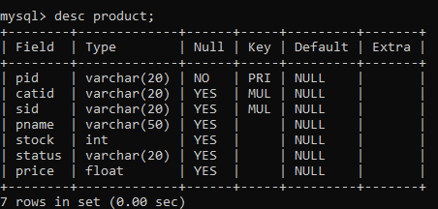

Orders Table

alter table orders add constraint ordcust_fk foreign key(cid) references customer(cid);

alter table orders add constraint ordpro_fk foreign key(pid) references product(pid);

alter table orders add constraint ordcour_fk foreign key(coid) references courrier(coid);

